Project Design Phase-II
Data Flow Diagram & User Stories

Date | 18 Feb 2026
Team ID | LTVIP2026TMIDS80588
Project Name | TransLingua: AI-Powered Multi-Language Translator
Maximum Marks | 4 Marks

Data Flow Diagrams:
A Data Flow Diagram (DFD) is a traditional visual representation of the information flows within a system. A neat and clear DFD can depict the right amount of the system requirement graphically. It shows how data enters and leaves the system, what changes the information, and where data is stored.
Example: (Simplified)
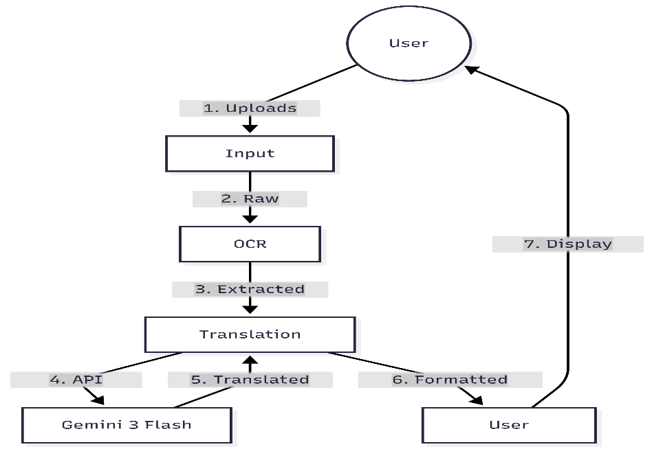

User Stories
Use the below template to list all the user stories for the product.
User Type | Functional Requirement (Epic) | User Story / Task | Acceptance criteria | Priority
Researcher | Document Translation | As a researcher, I want to upload a foreign PDF paper | I can read the translated paper in my native language | High
Traveler | Vision Capture | As a traveler, I want to take a photo of a sign | I can see the meaning of the sign instantly on screen. | High
General User | Manual Input | As a user, I want to paste text for quick translation | The text is translated accurately into the target language | Medium
Admin | System Stability | As an admin, I want the app to switch models if one fails | The user never sees a "404/429" error message | High

Python google-genai SDK: https://pypi.org/project/google-genai/

